INTRODUCTION TO DATA COMMUNICATIONS AND NETWORKING
Introduction to Data Communications:
- In Data Communications, data generally are defined as information that is stored in digital form.
- Data communications is the process of transferring digital information between two or more points.
- Information is defined as the knowledge or intelligence.
- Data communications can be summarized as the transmission, reception, and processing of digital information.
- For data communications to occur, the communicating devices must be part of a communication system made up of a combination of hardware (physical equipment) and software (programs).
- The effectiveness of a data communications system depends on four fundamental characteristics: delivery, accuracy, timeliness, and jitter.
Fundamental characteristics [Effectiveness of DC]:
- Delivery-correct destination
- Accuracy-deliver data accurately
- Timeliness- delivery data in timely manner
- Jitter-variation in packet arrival time.
Components of Data Communication
A data communications system has five components:
- Message: The message is the information (data) to be communicated. Popular forms of information include text, numbers, pictures, audio, and video.
- Sender: The sender is the device that sends the data message. It can be a computer, workstation, telephone handset, video camera, and so on.
- Receiver: The receiver is the device that receives the message. It can be a computer, workstation, telephone handset, television, and so on.
- Transmission medium/ Communication Channel: The transmission medium is the physical path by which a message travels from sender to receiver. Some examples of transmission media include twisted-pair wire, coaxial cable, fiber-optic cable, and radio waves.
- Protocol: A protocol is a set of rules that govern data communications. It represents an agreement between the communicating devices.
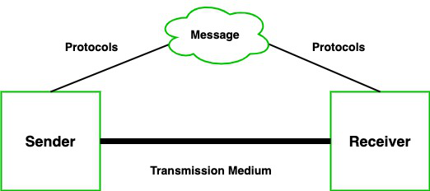
Standards Organizations for Data Communications:
An association of organizations, governments, manufacturers and users form the standards organizations and are responsible for developing, coordinating and maintaining the standards. The intent is that all data communications equipment manufacturers and users comply with these standards. The primary standards organizations for data communication are:
- International Standard Organization (ISO)
- It is comprised mainly of members from the standards committee of various governments throughout the world.
- It is even responsible for developing models which provides high level of system compatibility, quality enhancement, improved productivity and reduced costs.
- The ISO is also responsible for endorsing and coordinating the work of the other standards organizations.
- International Telecommunications Union-Telecommunication Sector (ITU-T)
- ITU-T is one of the four permanent parts of the International Telecommunications Union based in Geneva, Switzerland.
- It has developed three sets of specifications: the V series for modem interfacing and data transmission over telephone lines, the X series for data transmission over public digital networks, email and directory services; the I and Q series for Integrated Services Digital Network (ISDN) and its extension Broadband ISDN.
- ITU-T membership consists of government authorities and representatives from many countries and it is the present standards organization for the United Nations.
- Institute of Electrical and Electronics Engineers (IEEE)
- IEEE is an international professional organization founded in United States and is compromised of electronics, computer and communications engineers.
- It is currently the world’s largest professional society with over 200,000 members.
- It develops communication and information processing standards with the underlying goal of advancing theory, creativity, and product quality in any field related to electrical engineering.
- American National Standards Institute (ANSI)
- ANSI is the official standards agency for the United States and is the U.S voting representative for the ISO.
- ANSI is a completely private, non-profit organization comprised of equipment manufacturers and users of data processing equipment and services.
- ANSI membership is comprised of people form professional societies, industry associations, governmental and regulatory bodies, and consumer goods.
- Electronics Industry Association (EIA)
- EIA is a non-profit U.S. trade association that establishes and recommends industrial standards.
- EIA activities include standards development, increasing public awareness, and lobbying and it is responsible for developing the RS (recommended standard) series of standards for data and communications.
- Telecommunications Industry Association (TIA)
- TIA is the leading trade association in the communications and information technology industry.
- It facilitates business development opportunities through market development, trade promotion, trade shows, and standards development.
- It represents manufacturers of communications and information technology products and also facilitates the convergence of new communications networks.
- Internet Architecture Board (IAB)
IAB earlier known as Internet Activities Board is a committee created by ARPA (Advanced Research Projects Agency) so as to analyze the activities of ARPANET whose purpose is to accelerate the advancement of technologies useful for U.S military.
IAB is a technical advisory group of the Internet Society and its responsibilities are:
- Oversees the architecture protocols and procedures used by the Internet.
- Manages the processes used to create Internet Standards and also serves as an appeal board for complaints regarding improper execution of standardization process.
- Responsible for administration of the various Internet assigned numbers
- Acts as a representative for Internet Society interest in liaison relationships with other organizations.
- Acts as a source of advice and guidance to the board of trustees and officers of Internet Society concerning various aspects of internet and its technologies.
- Internet Engineering Task Force (IETF)
The IETF is a large international community of network designers, operators, vendors and researchers concerned with the evolution of the Internet architecture and smooth operation of the Internet.
- Internet Research Task Force (IRTF)
The IRTF promotes research of importance to the evolution of the future Internet by creating focused, long-term and small research groups working on topics related to Internet protocols, applications, architecture and technology.

Layered Network Architecture:
- To reduce the design complexity, most of the networks are organized as a series of layers or levels, each one build upon one below it.
- The basic idea of a layered architecture is to divide the design into small pieces.
- Each layer adds to the services provided by the lower layers in such a manner that the highest layer is provided a full set of services to manage communications and run the applications.
- The benefits of the layered models are modularity and clear interfaces.
- The basic elements of a layered model are services, protocols and interfaces.
- A service is a set of actions that a layer offers to another (higher) layer.
- Protocol is a set of rules that a layer uses to exchange information with a peer entity.
- The messages from one layer to another are sent through those interfaces.
- In a n-layer architecture, layer n on one machine carries on conversation with the layer n on other machine.
- Basically, a protocol is an agreement between the communicating parties on how communication is to proceed.
- In reality, no data is transferred from layer n on one machine to layer n of another machine. Instead, each layer passes data and control information to the layer immediately below it, until the lowest layer is reached.
- Below layer-1 is the physical layer through which actual communication occurs.
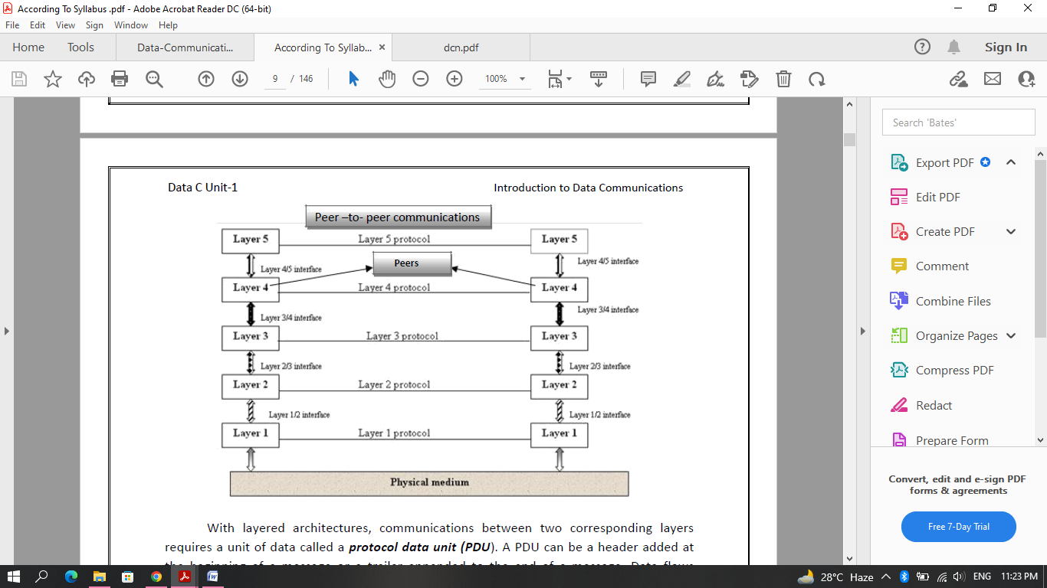
- Communications between two corresponding layers requires a unit of data called a protocol data unit (PDU).
- A PDU can be a header added at the beginning of a message or a trailer appended to the end of a message.
- As data passes from one layer into another, headers and trailers are added and removed from the PDU.
- This process of adding or removing PDU information is called encapsulation/decapsulation.
- Between each pair of adjacent layers there is an interface.
- The interface defines which primitives operations and services the lower layer offers to the upper layer adjacent to it.
- A set of layers and protocols is known as network architecture.
- A list of protocols used by a certain system, one protocol per layer, is called protocol stack.
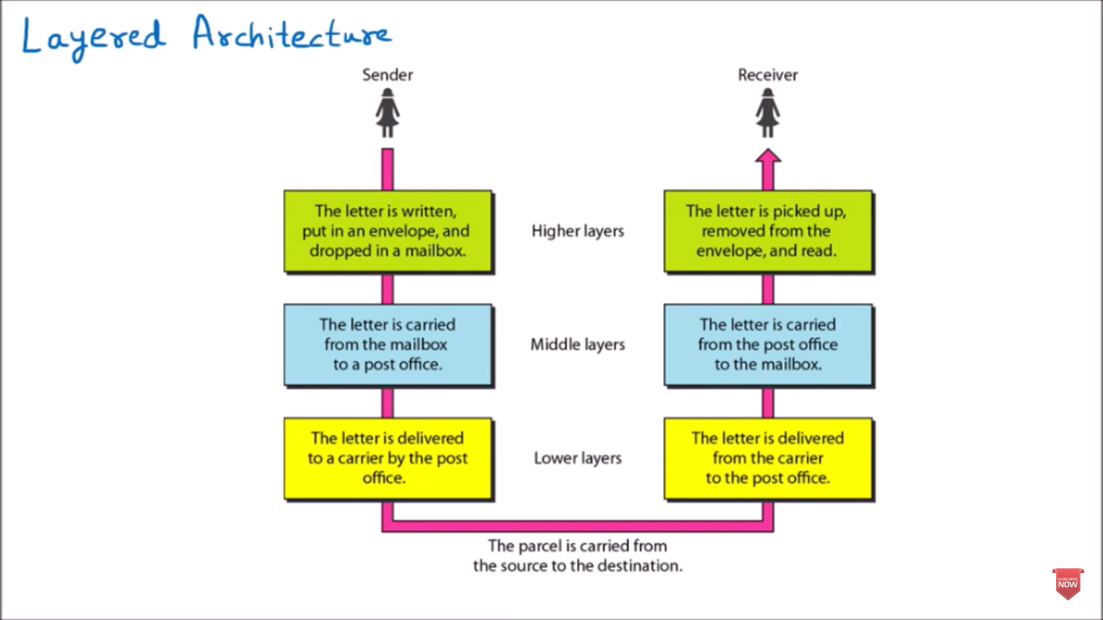

Open Systems Interconnection (OSI):
- OSI stands for Open Systems Interconnection.
- It was developed by the ISO – International Organization for Standardization- in 1984.
- It is a 7-layer architecture with each layer having specific functionality to perform.
- All these 7 layers work collaboratively to transmit the data from one person to another across the globe.
- The term "open" denotes the ability to connect any two systems that conform to the reference model and associated standards.
The seven layers are:
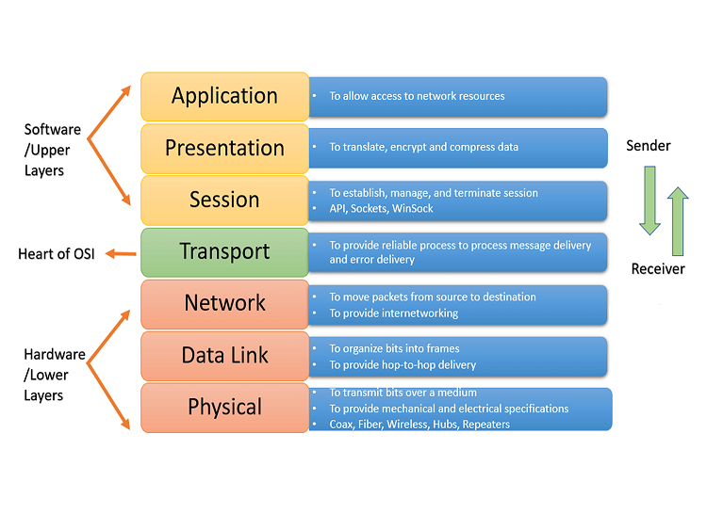
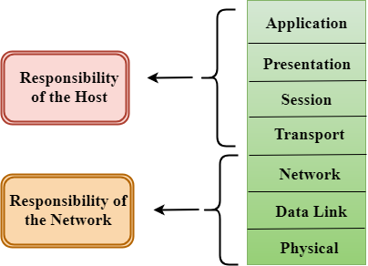

- The lower 4 layers (transport, network, data link, and physical —Layers 4, 3, 2, and 1) are concerned with the flow of data from end to end through the network.
- The upper three layers of the OSI model (application, presentation, and session—Layers 7, 6, and 5) are oriented more toward services to the applications.
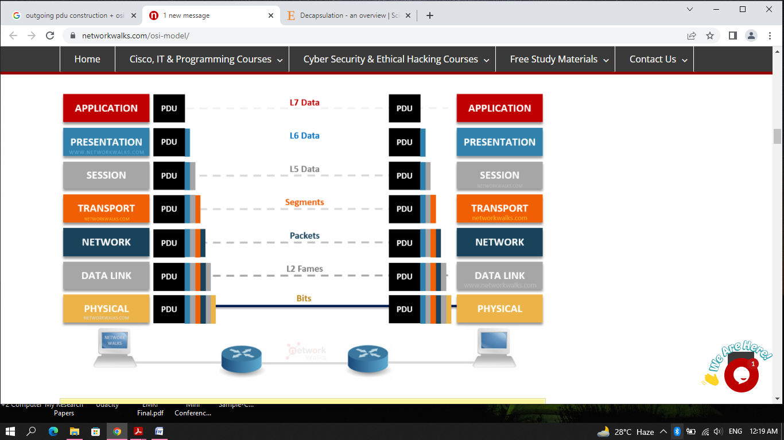

- As the message travels from device A to device B, it may pass through many intermediate nodes. These intermediate nodes usually involve only the first three layers of the OSI model.
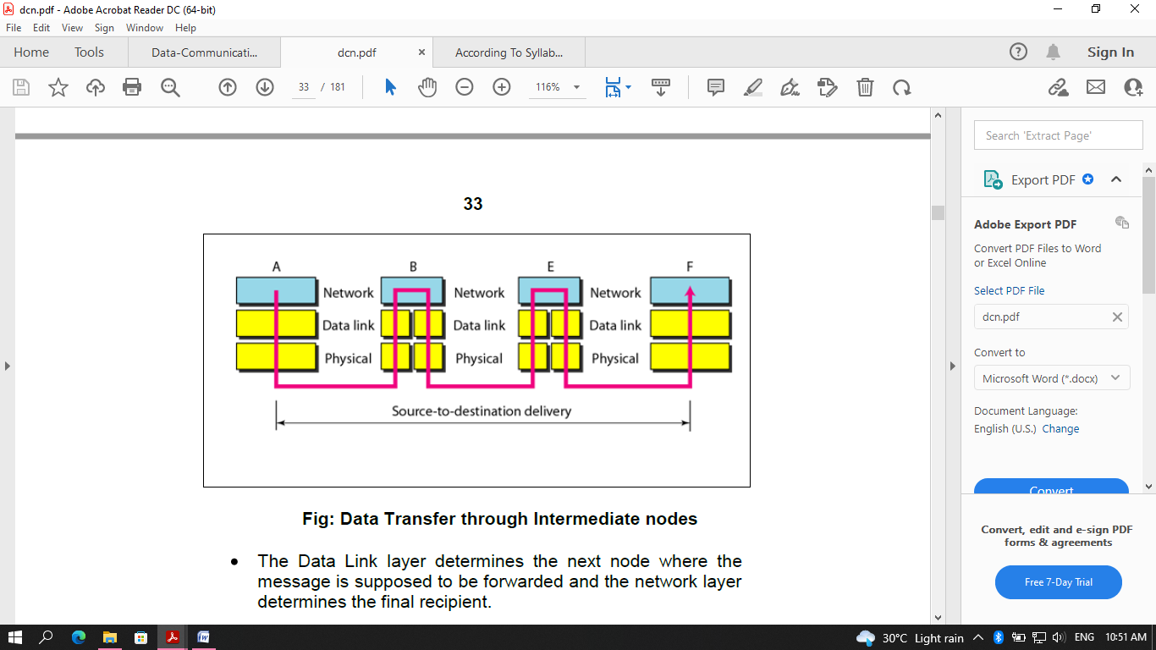
- The Data Link layer determines the next node where the message is supposed to be forwarded and the network layer determines the final recipient.
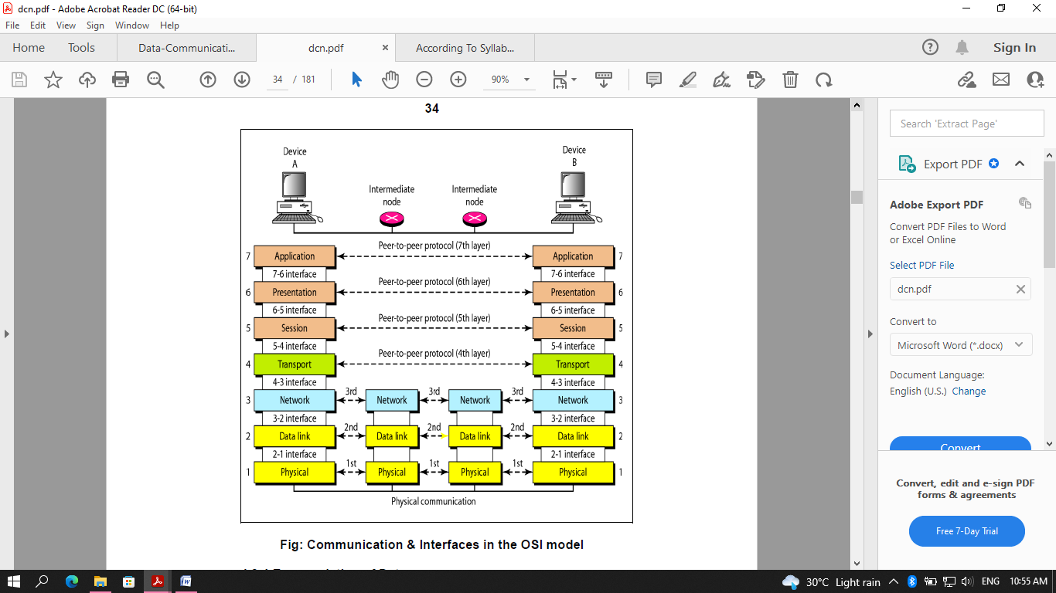

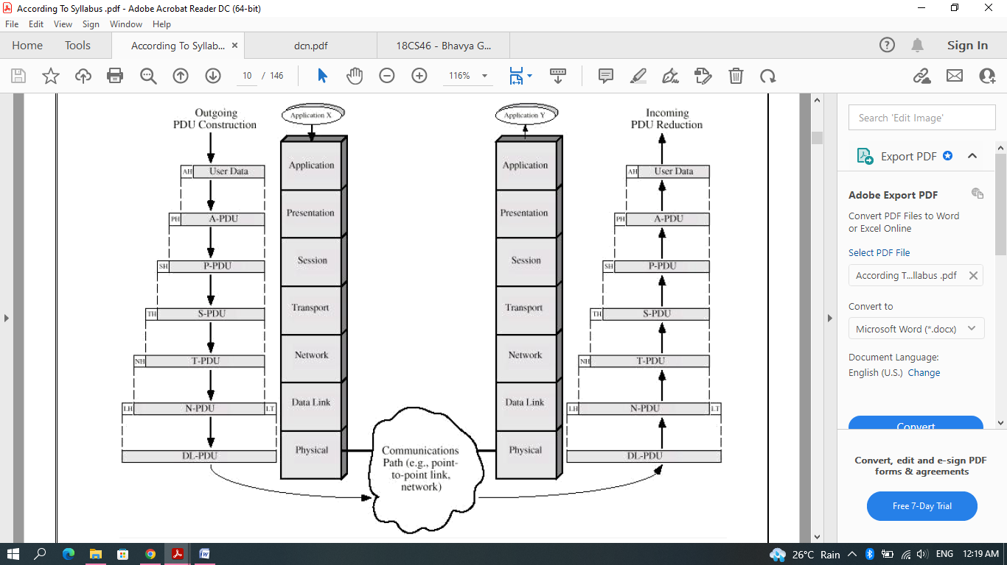

Physical Layer
- It is the lowest layer of the OSI model.
- The physical layer is responsible for the movement of individual bits from one node to another node.
- Transmission media is another hidden layer under the physical layer.
- It establishes, maintains, and deactivates the physical connection.
- Two devices are connected by a transmission medium (cable or air).
- The transmission medium does not carry bits; it carries electrical or optical signals.
- The physical layer
- Receives bits from the data-link layer &
- Sends through the transmission media.

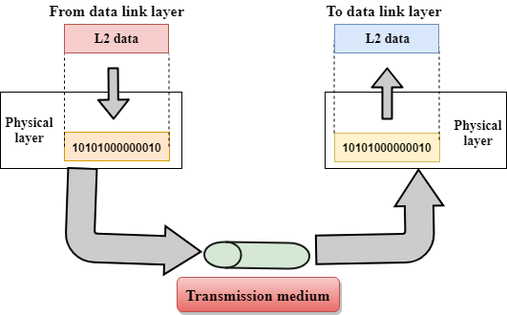

Functions of a Physical layer:

Line Configuration: It defines the way in which two or more devices can be connected physically.

Data Transmission: It defines the transmission mode, whether it is simplex, half-duplex, or full-duplex mode between the two devices on the network.

Topology: It defines the way network devices are arranged.

Signals: It determines the type of signal used for transmitting the information.

Data-Link Layer
- This layer is responsible for the error-free transfer of data frames.
- The data link layer transforms the physical layer, a raw transmission facility, into a reliable link and is responsible for node-to-node delivery.
- It makes the physical layer appear error-free to the upper layer (network layer).
- The data link layer packages data from the physical layer into groups called blocks, frames, or packets.
- If frames are to be distributed to different systems on the network, the data link layer adds a header to the frame to define the physical address of the sender (source address) and/or receiver (destination address) of the frame.

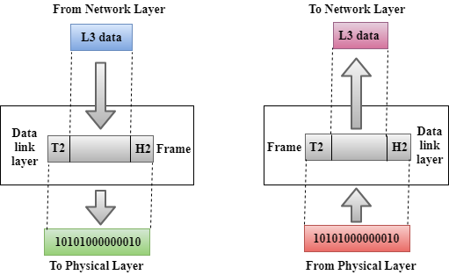

Functions of the Data-link layer
- Framing: The data link layer translates the physical layer's raw bit stream into packets known as Frames. The Data link layer adds the header and trailer to the frame. The header, which is added to the frame, contains the hardware destination and source address.

- Physical Addressing: The Data link layer adds a header to the frame that contains a destination address. The frame is transmitted to the destination address mentioned in the header.
- Flow Control: Flow control is the main functionality of the Data-link layer. It is the technique through which the constant data rate is maintained on both sides so that no data gets corrupted. It ensures that the transmitting station, such as a server with a higher processing speed, does not exceed the receiving station, with a lower processing speed.
- Error Control: Error control is achieved by adding a calculated value, CRC (Cyclic Redundancy Check), to the Data link layer's trailer, which is added to the message frame before it is sent to the physical layer. If any error seems to occur, then the receiver sends the acknowledgment for the retransmission of the corrupted frames.
- Access Control: When two or more devices are connected to the same communication channel, then the data link layer protocols are used to determine which device has control over the link at a given time.
Network Layer
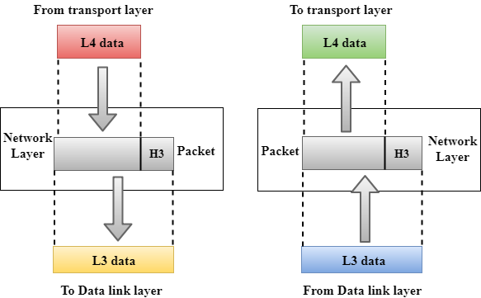
- It is in layer 3 that manages device addressing, tracks the location of devices on the network.
- The network layer provides details that enable data to be routed between devices in an environment using multiple networks, sub-networks, or both.
- This is responsible for addressing messages and data so they are sent to the correct destination, and for translating logical addresses and names (like a machine name) into physical addresses.
- This layer is also responsible for finding a path through the network to the destination computer.
- Networking components that operate at the network layer include routers and their software.

Functions of the Network Layer:
- Internetworking: It provides a logical connection between different devices.
- Addressing: A Network layer adds the source and destination addresses to the header of the frame. An address is used to identify the device on the Internet.
- Routing: Routing is the major component of the network layer, and it determines the optimal path out of the multiple paths from the source to the destination.
- Packetizing: A Network Layer receives the packets from the upper layer and converts them into packets. This process is known as Packetizing. It is achieved by the Internet Protocol (IP).
Transport Layer
- The Transport layer, in Layer 4, ensures that messages are transmitted in the order in which they are sent and there is no duplication of data.
- The transport layer controls and ensures the end-to-end integrity of the data message propagated through the network between two devices, providing the reliable, transparent transfer of data between two endpoints.
- The main responsibility of the transport layer is to transfer the data completely.
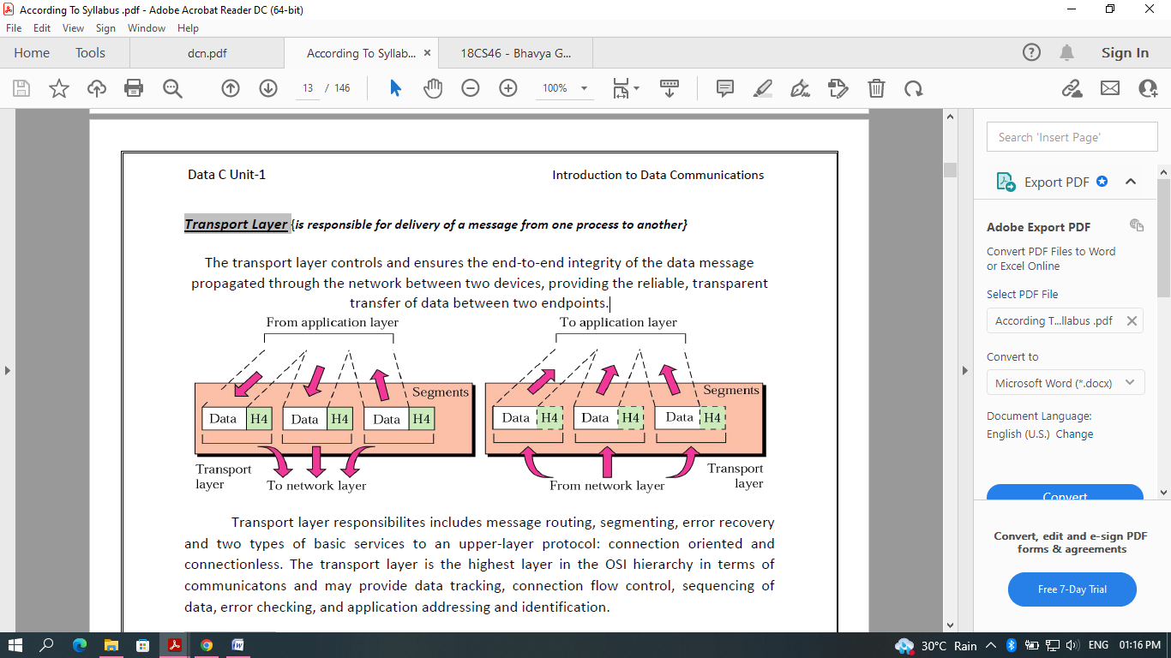
The two protocols used in this layer are:
- Transmission Control Protocol
  - It is a standard protocol that allows the systems to communicate over the Internet.
  - It establishes and maintains a connection between hosts.
  - When data is sent over the TCP connection, then the TCP protocol divides the data into smaller units known as segments.
  - Each segment travels over the internet using multiple routes, and they arrive in different orders at the destination.
  - Reorders the packets in the correct order at the receiving end.
- User Datagram Protocol
  - User Datagram Protocol is a transport layer protocol.
  - It is an unreliable transport protocol as in this case receiver does not send any acknowledgment when the packet is received, the sender does not wait for any acknowledgment. Therefore, this makes a protocol unreliable.

Functions of Transport Layer:
- Service-point addressing: The transport layer adds the header that contains the address known as a service-point address or port address. The responsibility of the network layer is to transmit the data from one computer to another computer and the responsibility of the transport layer is to transmit the message to the correct process.
- Segmentation and reassembly: When the transport layer receives the message from the upper layer, it divides the message into multiple segments, and each segment is assigned with a sequence number that uniquely identifies each segment. When the message has arrived at the destination, then the transport layer reassembles the message based on their sequence numbers.
- Connection control: Transport layer provides two services Connection-oriented service and connectionless service. A connectionless service treats each segment as an individual packet, and they all travel in different routes to reach the destination. A connection-oriented service makes a connection with the transport layer at the destination machine before delivering the packets. In connection-oriented service, all the packets travel in the single route.
- Flow control: The transport layer also responsible for flow control but it is performed end-to-end rather than across a single link.
- Error control: The transport layer is also responsible for Error control. Error control is performed end-to-end rather than across the single link. The sender transport layer ensures that message reach at the destination without any error.

Session Layer
- It defines how to start, control and end conversations (called sessions) between applications.
- The Session layer is used to establish, maintain and synchronizes the interaction between communicating devices.
- Session responsibilities include network log-on and log-off procedures and user authentication.
- Session layer characteristics include virtual connections between applications, entities, synchronization of data flow for recovery purposes, creation of dialogue units and activity units, connection parameter negotiation, and partitioning services into functional groups.
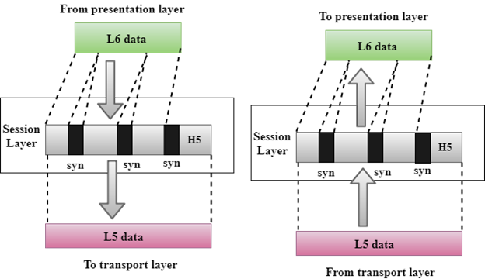

Functions of Session layer:
- Dialog control: it allows the communication between two processes which can be either half-duplex or full-duplex.
- Synchronization: Session layer adds some checkpoints when transmitting the data in a sequence. If some error occurs in the middle of the transmission of data, then the transmission will take place again from the checkpoint. This process is known as Synchronization and recovery.

Presentation Layer
- Responsible for translation, compression, and encryption.
- The presentation layer at sending side receives the data from the application layer adds header which contains information related to encryption and compression and sends it to the session layer.
- At the receiving side, the presentation layer receives data from the session layer decompresses and decrypts the data as required and translates it back as per the encoding scheme used at the receiver.
- Presentation functions include data file formatting, encoding, encryption and decryption of data messages, dialogue procedures, data compression algorithms, synchronization, interruption, and termination.
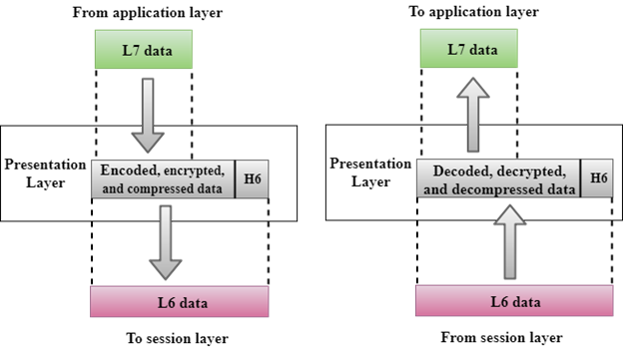

Functions of Presentation layer:
- Translation: The processes in two systems exchange the information in the form of character strings, numbers and so on. Different computers use different encoding methods, the presentation layer handles the interoperability between the different encoding methods. It converts the data from sender-dependent format into a common format and changes the common format into receiver-dependent format at the receiving end.
- Encryption: Encryption is needed to maintain privacy. Encryption is a process of converting the sender-transmitted information into another form and sends the resulting message over the network.
- Compression: Data compression is a process of compressing the data, i.e., it reduces the number of bits to be transmitted. Data compression is very important in multimedia such as text, audio, video.

Application Layer
- Responsible for providing services to the user.
- An application layer serves as a window for users and application processes to access network service.
- It handles issues such as network transparency, resource allocation, etc.
- An application layer is not an application, but it performs the application layer functions.
- This layer provides the network services to the end-users.

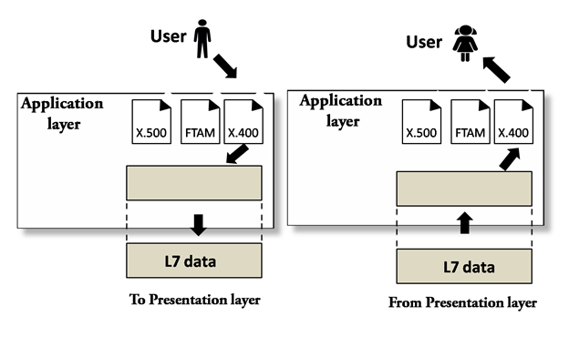
- X. 400 (Electronic Mail Protocol), X. 500 (Directory Server Protocol)

Functions of Application layer:
- File transfer, access, and management (FTAM): An application layer allows a user to access the files in a remote computer, to retrieve the files from a computer and to manage the files in a remote computer.
- Mail services: An application layer provides the facility for email forwarding and storage.
- Directory services: An application provides the distributed database sources and is used to provide that global information about various objects.

Data Communication Circuits
- Data communications circuits utilize electronic communications equipment and facilities to interconnect digital computer equipment.
- Communication facilities are physical means of interconnecting stations and are provided to data communications users through
- public telephone networks (PTN),
- public data networks (PDN), and
- a multitude of private data communications systems.

Two-station data communications circuit. The main components are:
Source: - This device generates the data to be transmitted. The source equipment provides a means for humans to enter data into system.
Examples: mainframe computer, personal computer, workstation etc.
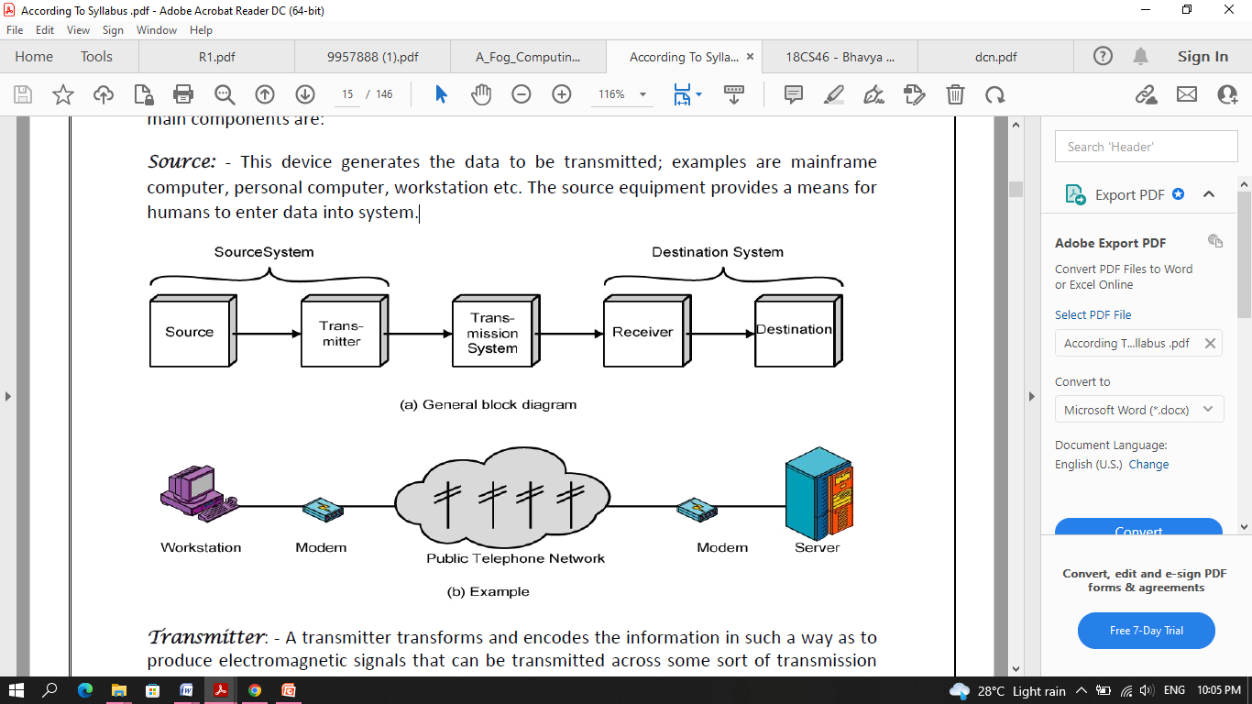
Transmitter: - A transmitter transforms and encodes the information in such a way as to produce electromagnetic signals that can be transmitted across some sort of transmission system.
For example: a modem takes a digital bit stream from an attached device such as a personal computer and transforms that bit stream into an analog signal that can be handled by t he telephone network.
Transmission medium: - The transmission medium carries the encoded signals from the transmitter to the receiver.
Example: Different types of transmission media include free-space radio transmission (i.e. all forms of wireless transmission) and physical facilities such as metallic and optical fibre cables.
Receiver: - The receiver accepts the signal from the transmission medium and converts it into a form that can be handled by the destination device.
For example: a modem will accept an analog signal coming from a network or transmission line and convert it into a digital bit stream.
Destination: - Takes the incoming data from the receiver and can be any kind of digital equipment like the source.

Serial and Parallel Data Transmission
There are two methods of transmitting digital data namely parallel and serial transmissions.
- In parallel data transmission, all bits of the binary data are transmitted simultaneously.
- For example, to transmit an 8-bit binary number in parallel from one unit to another, eight transmission lines are required.
- Each bit requires its own separate data path.
- All bits of a word are transmitted at the same time.
- This method of transmission can move a significant amount of data in a given period of time.
- Its disadvantage is the large number of interconnecting cables between the two units.
- For large binary words, cabling becomes complex and expensive.
- Long multi-wire cables are not only expensive, but also require special interfacing to minimize noise and distortion problems.
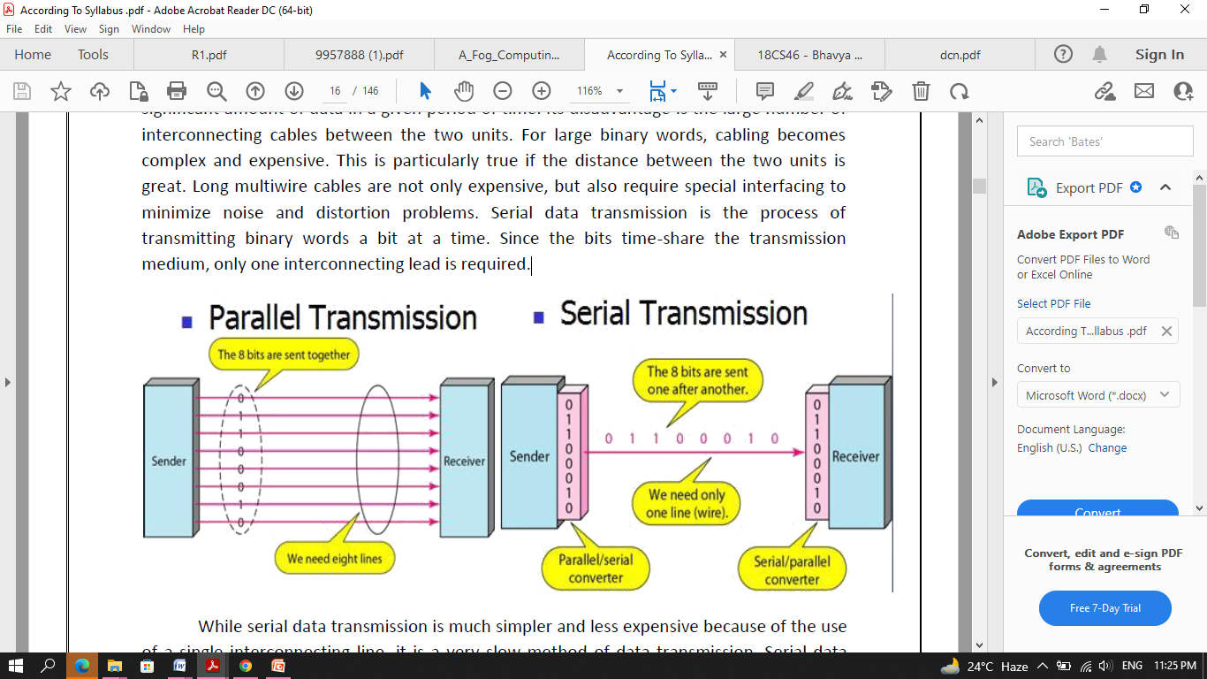

- Serial data transmission is the process of transmitting binary words a bit at a time.
- Since the bits time-share the transmission medium, only one interconnecting lead is required.
- While serial data transmission is much simpler and less expensive because of the use of a single interconnecting line, it is a very slow method of data transmission.
- Serial data transmission is useful in systems where high speed is not a requirement.
- Parallel communication is used for short-distance data communications and within a computer, and serial transmission is used for long-distance data communications.
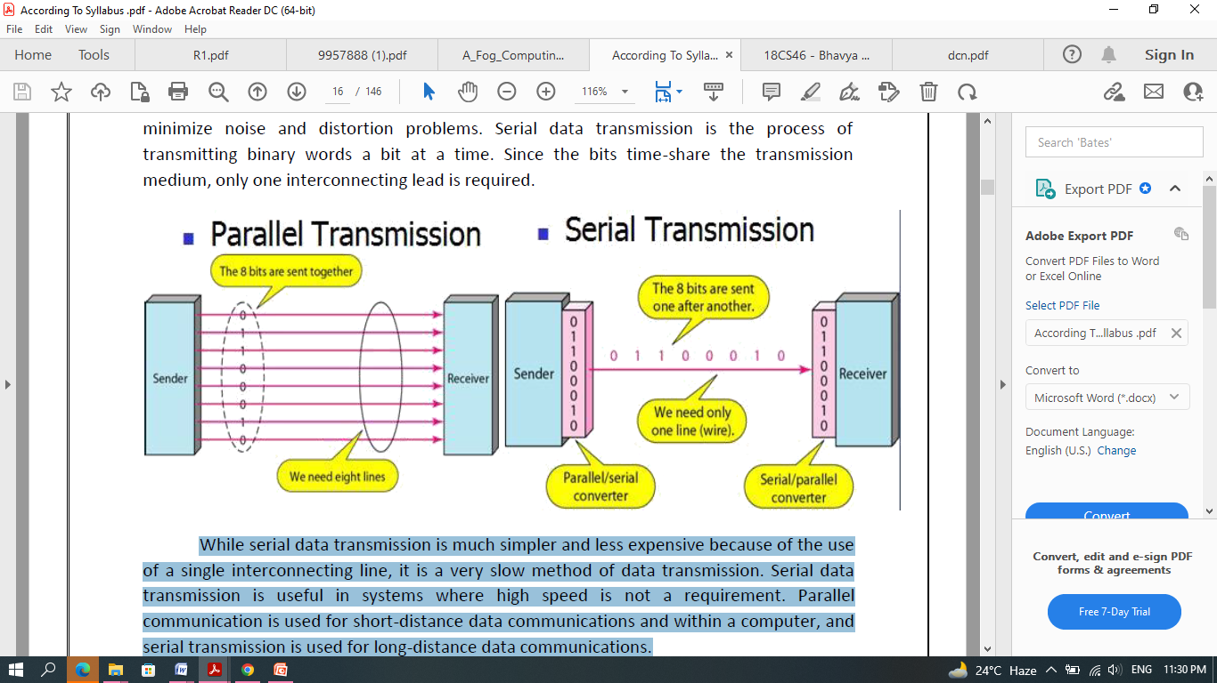
Data Communication Circuit Arrangements
A data communications circuit can be described in terms of circuit configuration and transmission mode.
Circuit Configurations
- Data communications networks can be generally categorized as either two points or multipoint.
- A two-point configuration involves only two locations or stations, whereas a multipoint configuration involves three or more stations.
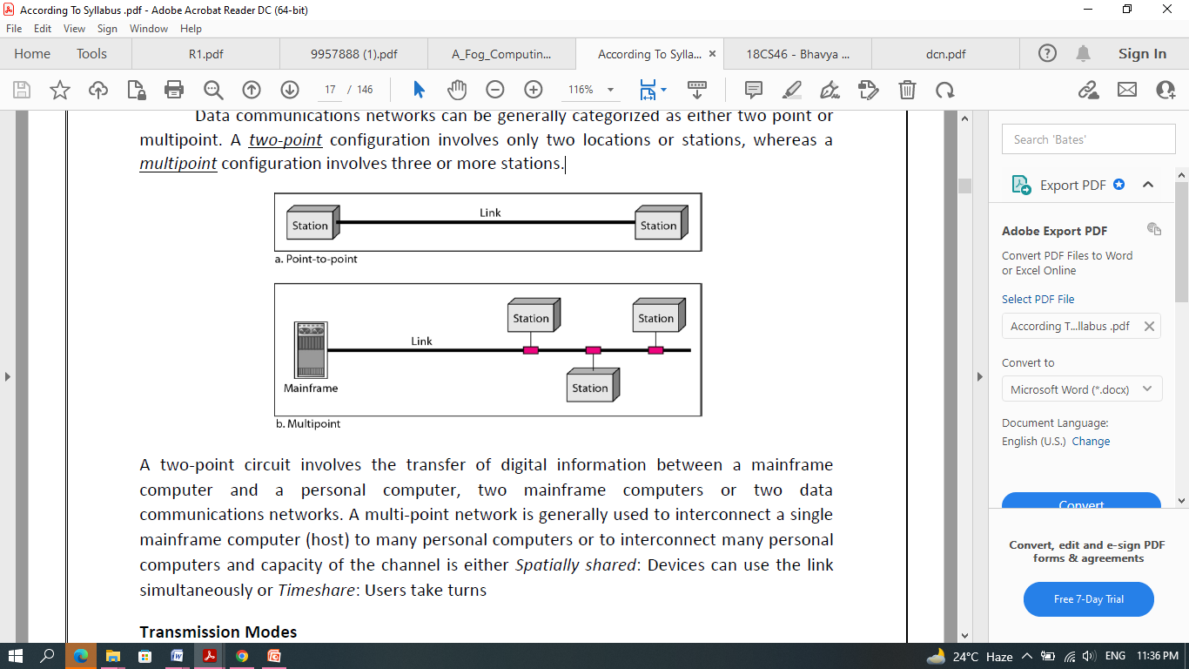
Transmission Modes
There are four modes of transmission for data communications circuits:
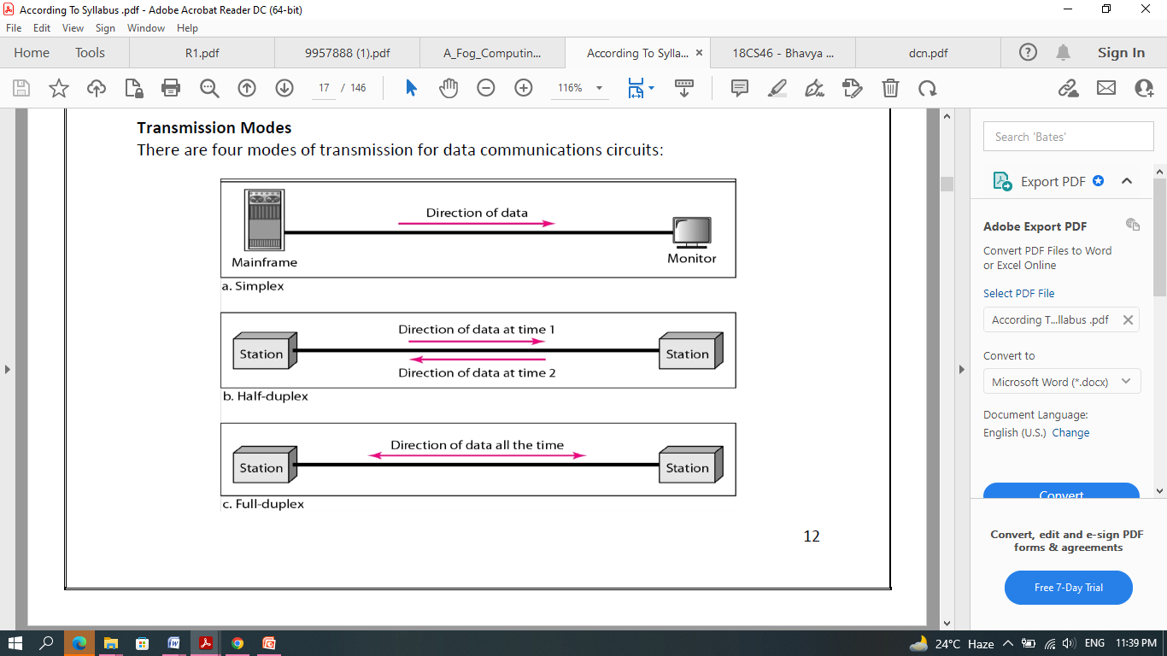
Simplex mode (SX):
- The communication is unidirectional, as on a one-way street.
- Only one of the two devices on a link can transmit; the other can only receive.
- Commercial radio broadcasting is an example.
- Simplex lines are also called receive-only, transmit-only or one-way-only lines.
Half-duplex (HDX):
- Each station can both transmit and receive, but not at the same time.
- When one device is sending, the other can only receive, and vice versa.
- The half-duplex mode is used in cases where there is no need for communication in both directions at the same time; the entire capacity of the channel can be utilized for each direction.
- Citizens band (CB) radio is an example where push to talk (PTT) is to be pressed or depressed while sending and transmitting.
Full-duplex mode (FDX):
- Called duplex, both stations can transmit and receive simultaneously.
- One common example of full-duplex communication is the telephone network.
- The full-duplex mode is used when communication in both directions is required all the time. The capacity of the channel must be divided between the two directions.
Full/full duplex (F/FDX):
- Transmission is possible in both directions at the same time but not between the same two stations (i.e. station 1 transmitting to station 2, while receiving from station 3).
- F/FDX is possible only on multipoint circuits.
- Postal system can be given as a person can be sending a letter to one address and receive a letter from another address at the same time.
Data Communications Networks
- Any group of computers connected together can be called a data communications network, and the process of sharing resources between computers over a data communications network is called networking.
- The most important considerations of a data communications network are performance, transmission rate, reliability and security.
Network Components, Functions, and Features
Servers:
- Servers are computers that hold shared files, programs and the network operating system.
- Servers provide access to network resources to all the users of the network and different kinds of servers are present.
Examples include file servers, print servers, mail servers, communication servers etc.
Clients:
- Clients are computers that access and use the network and shared network resources.
- Client computers are basically the customers (users) of the network, as they request and receive service from the servers.
Shared Data:
- Shared data are data that file servers provide to clients, such as data files, printer access programs, and e-mail.
Shared Printers and other peripherals:
- These are hardware resources provided to the users of the network by servers.
- Resources provided include data files, printers, software, or any other items used by the clients on the network.
Network interface card:
- Every computer in the network has a special expansion card called network interface card (NIS), which prepares and sends data, receives data, and controls data flow between the computer and the network.
- While transmitting, NIC passes frames of data on to the physical layer and on the receiver side, the NIC processes bits received from the physical layer and processes the message based on its contents.
Local operating system:
- A local operating system allows personal computers to access files, print to a local printer, and use one or more disk and CD drives that are located on the computer.
Examples are MS-DOS, PC-DOS, UNIX, Macintosh, OS/2, Windows 95, 98, XP and Linux.
Network operating system:
- The NOS is a program that runs on computers and servers that allows the computers to communicate over a network.
- The NOS provides services to clients such as log-in features, password authentication, printer access, network administration functions and data file sharing.
Network Models
Computer networks can be represented with two basic network models: peer-to-peer client/server and dedicated client/server.
Peer-to-peer client/server network:
- Here, all the computers share their resources, such as hard drives, printers and so on with all the other computers on the network.
- Individual resources like disk drives, CD-ROM drives, and even printers are transformed into shared, collective resources that are accessible from every PC.
- Unlike client-server networks, where network information is stored on a centralized file server PC and made available to tens, hundreds, or thousands client PCs, the information stored across peer-to-peer networks is uniquely decentralized.
- Because peer-to-peer PCs have their own hard disk drives that are accessible by all computers, each PC acts as both a client (information requestor) and a server (information provider).
- The peer-to-peer network is an appropriate choice when there are fewer than 10 users on the network, security is not an issue and all the users are located in the same general area.
The advantages of peer-to-peer over client-server NOSs include:
- No need for a network administrator
- Network is fast/inexpensive to setup & maintain
- Each PC can make backup copies of its data to other PCs for security.
- Easiest type of network to build, peer-to-peer is perfect for both home and office use.
Dedicated client/server network:
- Here, one computer is designated as server and the rest of the computers are clients.
- Dedicated Server Architecture can improve the efficiency of client server systems by using one server for each application that exists within an organization.
- The designated servers store all the networks shared files and applications programs and function only as servers and are not used as a client or workstation.
- Client computers can access the servers and have shared files transferred to them over the transmission medium.
- In some client/server networks, client computers submit jobs to one of the servers and once they process the jobs, the results are sent back to the client computer.

Network Topologies
- In computer networking, topology refers to the layout of connected devices, i.e. how the computers, cables, and other components within a data communications network are interconnected, both physically and logically.
- The physical topology describes how the network is actually laid out, and the logical topology describes how the data actually flow through the network.
- Two most basic topologies are point-to-point and multipoint.
- A point-to-point topology usually connects two mainframe computers for high-speed digital information.
- A multipoint topology connects three or more stations through a single transmission medium and some examples are star, bus, ring, mesh and hybrid.
Star topology:
- A star topology is designed with each node (file server, workstations, and peripherals) connected directly to a central network hub, switch, or concentrator.
- Data on a star network passes through the hub, switch, or concentrator before continuing to its destination.
- The hub, switch, or concentrator manages and controls all functions of the network.
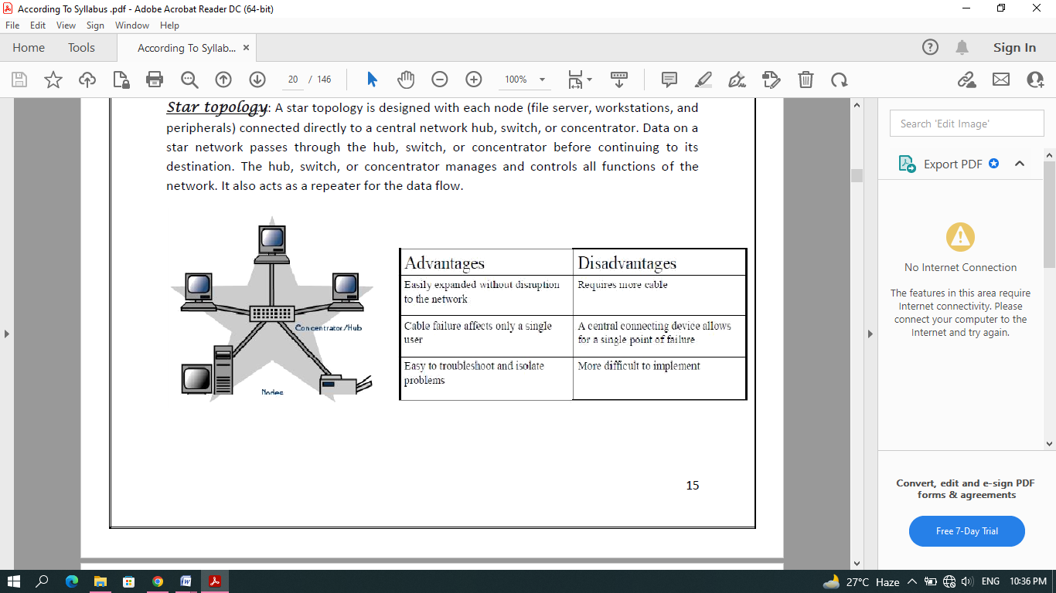
Bus topology:
- Bus networks use a common backbone to connect all devices.
- A single cable, (the backbone) functions as a shared communication medium that devices attach or tap into with an interface connector.
- A device wanting to communicate with another device on the network sends a broadcast message onto the wire that all other devices see, but only the intended recipient actually accepts and processes the message.
- The bus topology is the simplest and most common method of interconnecting computers.
- A bus topology is also known as multidrop or linear bus or a horizontal bus.
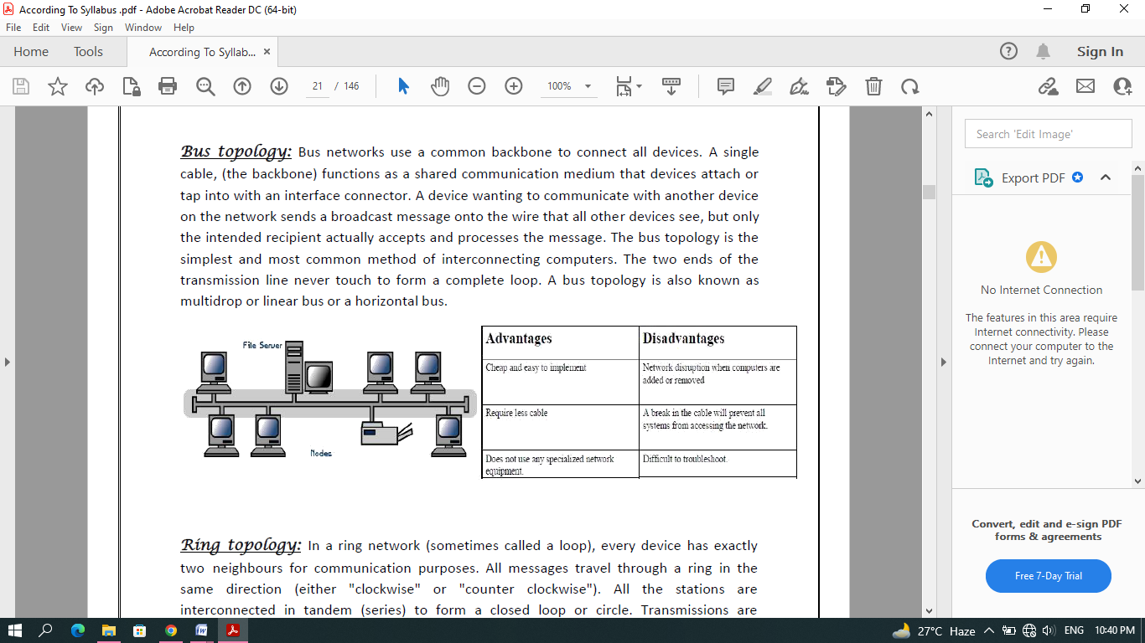
Ring topology:
- In a ring network (sometimes called a loop), every device has exactly two neighbours for communication purposes.
- All messages travel through a ring in the same direction (either "clockwise" or "counter clockwise").
- All the stations are interconnected in tandem (series) to form a closed loop or circle.
- Transmissions are unidirectional and must propagate through all the stations in the loop.
- Each computer acts like a repeater and the ring topology is similar to bus or star topologies.
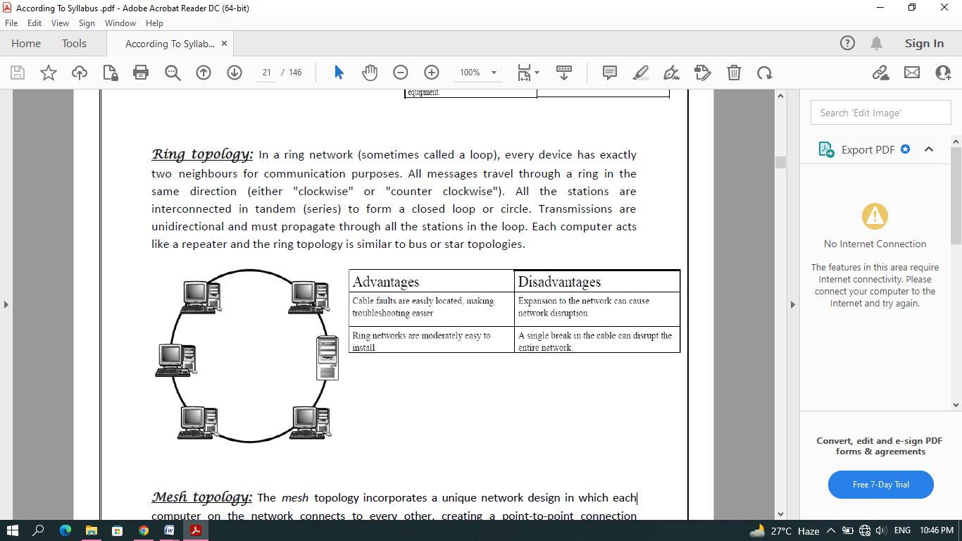
Mesh topology:
- The mesh topology incorporates a unique network design in which each computer on the network connects to every other, creating a point-to-point connection between every device on the network.
- Unlike each of the previous topologies, messages sent on a mesh network can take any of several possible paths from source to destination.
- A mesh network in which every device connects to every other is called a full mesh.
- A disadvantage is that, a mesh network with n nodes must have n(n-1)/2 links and each node must have n-1 I/O ports (links).
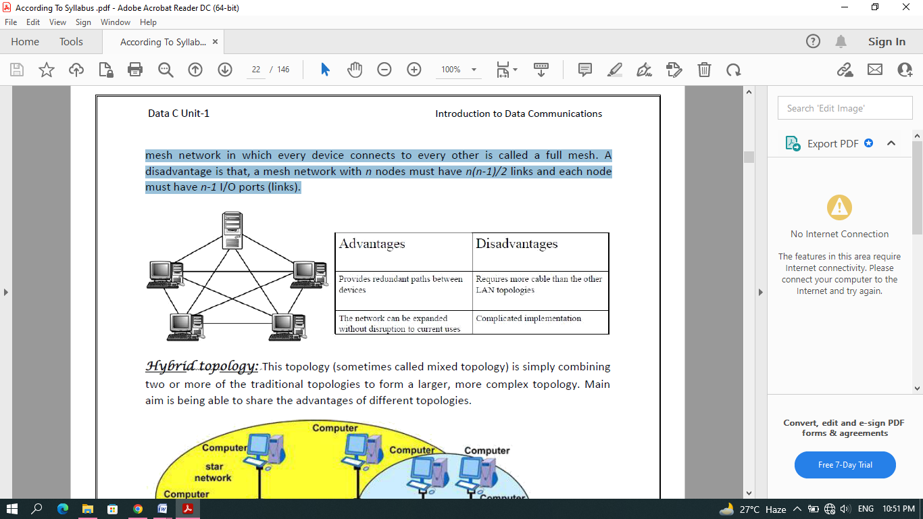
Hybrid topology:
- This topology (sometimes called mixed topology) is simply combining two or more of the traditional topologies to form a larger, more complex topology.
- Main aim is being able to share the advantages of different topologies.
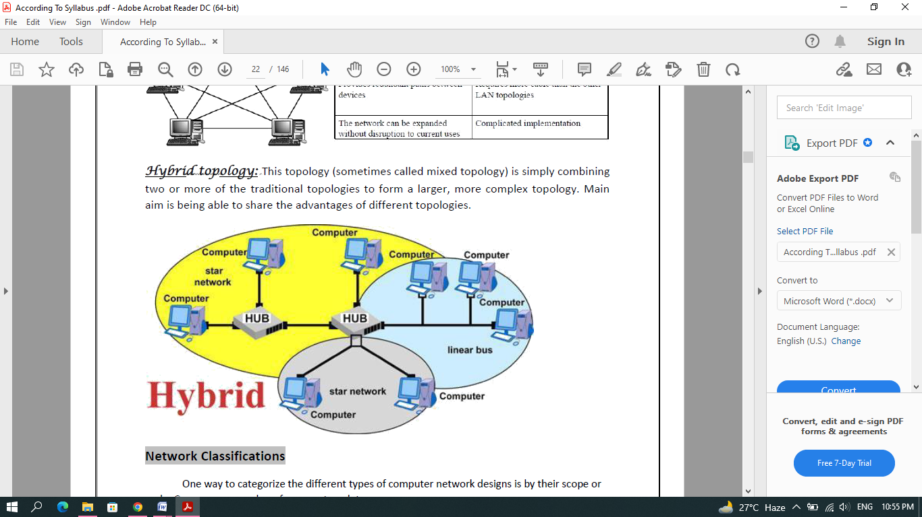

Network Classifications
One way to categorize the different types of computer network designs is by their scope or scale.
Common examples of area network types are:
- LAN: Local Area Network
- WLAN: Wireless Local Area Network
- WAN: Wide Area Network
- MAN: Metropolitan Area Network
- SAN: Storage Area Network, System Area Network, Server Area Network, or sometimes Small Area Network
- CAN: Campus Area Network, Controller Area Network, or sometimes Cluster Area Network
- PAN: Personal Area Network
- DAN: Desk Area Network
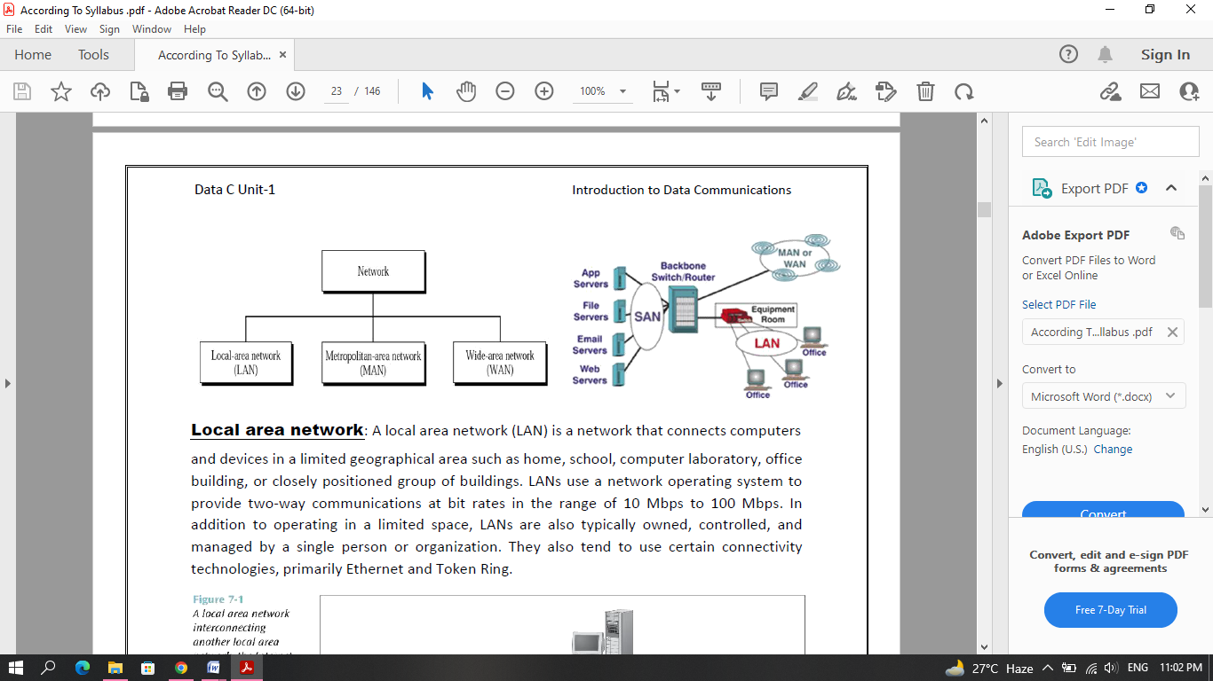
Local area network:
- A local area network (LAN) is a network that connects computers and devices in a limited geographical area such as home, school, computer laboratory, office building, or closely positioned group of buildings.
- LANs use a network operating system to provide two-way communications at bit rates in the range of 10 Mbps to 100 Mbps.
- In addition to operating in a limited space, LANs are also typically owned, controlled, and managed by a single person or organization.
- They also tend to use certain connectivity technologies, primarily Ethernet and Token Ring.

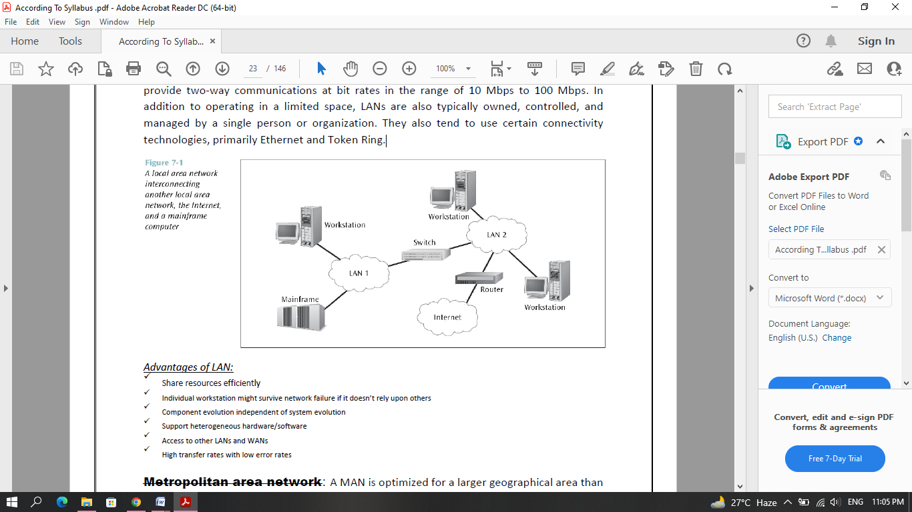
Advantages of LAN:
- Share resources efficiently
- Support heterogeneous hardware/software
- Access to other LANs and WANs
- High transfer rates with low error rates
Metropolitan area network:
- A MAN is optimized for a larger geographical area than a LAN, ranging from several blocks of buildings to entire cities.
- Its geographic scope falls between a WAN and LAN.
- MANs typically operate at speeds of 1.5 Mbps to 10 Mbps and range from five miles to a few hundred miles in length.
- Examples of MANs are FDDI (fibre distributed data interface)
Wide area network:
- Wide area networks are the oldest type of data communications network that provide relatively slow-speed, long-distance transmission of data, voice and video information over relatively large and widely dispersed geographical areas, such as country or entire continent.
- WANs interconnect routers in different locations.
- A WAN differs from a LAN in several important ways.
- Most WANs (like the Internet) are not owned by any one organization but rather exist under collective or distributed ownership and management.
- WANs tend to use technology like ATM, Frame Relay and X.25 for connectivity over the longer distances.
Global area network:
- A GAN provides connections between countries around the entire globe.
- Internet is a good example and is essentially a network comprised of other networks that interconnect virtually every country in the world.
- GANs operate from 1.5 Mbps to 100Gbps and cover thousands of miles.
Campus Area Network: - a network spanning multiple LANs but smaller than a MAN, such as on a university or local business campus.
Storage Area Network: - connects servers to data storage devices through a technology like Fibre Channel.
System Area Network: - Links high-performance computers with high-speed connections in a cluster configuration. Also known as Cluster Area Network.
Building backbone: - It is a network connection that normally carries traffic between departmental LANs within a single company. It consists of a switch or router to provide connectivity to other networks such as campus backbones, enterprise backbones, MANs, WANs etc
Camus backbone: - It is a network connection used to carry traffic to and from LANs located in various buildings on campus. It normally uses optical fibre cables for the transmission media between buildings and operates at relatively high transmission rates.
Enterprise networks: - It includes some or all of the above networks and components connected in a cohesive and manageable fashion.

